Concept Development Lessons
How can I help students develop a deeper understanding of Mathematics?
Handouts for teachers

Contents
1 Assessment tasks 2
2 Sample student work 5
3 Sample follow-up questions 8
4 Generalizations commonly made by students 11
5 Principles to discuss 12
6 Structure of the Concept lessons 13
7 Some genres of activity used in the Concept Lessons 14
8 Classifying mathematical objects 15
9 Interpreting multiple representations 16
10 Evaluating mathematical statements 20
11 Students modifying a given problem 21
12 Students creating problems for each other 22

Handout 1: Assessment tasks

Assessment Task: Distance time graphs

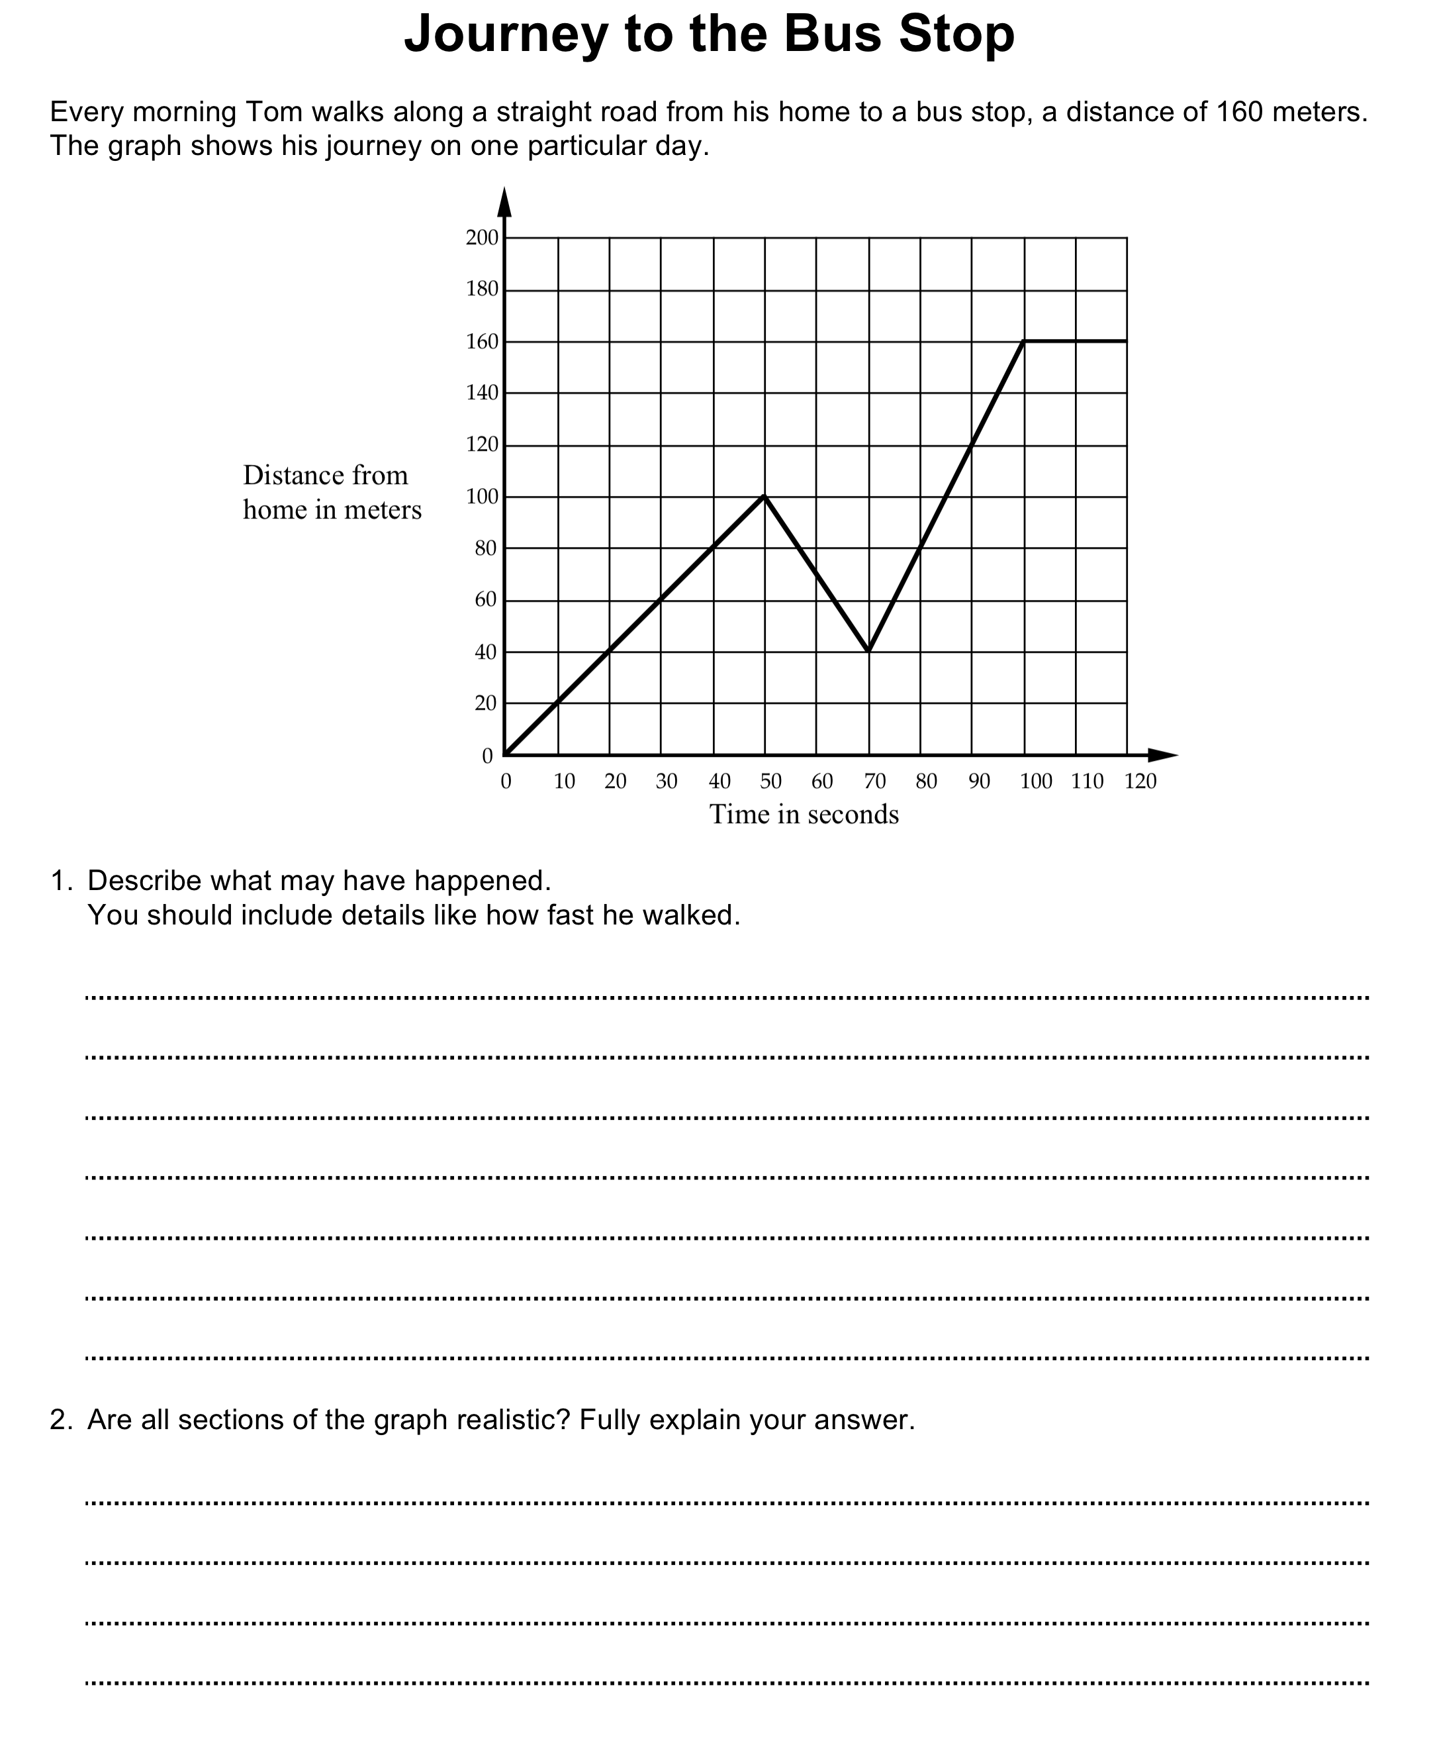

Assessment Task: Percent changes

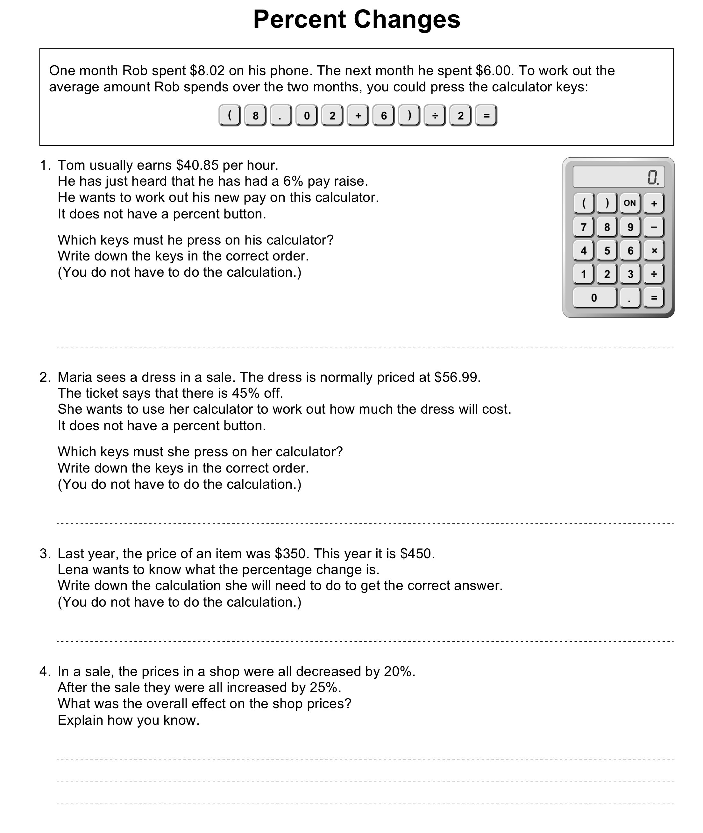

Assessment Task: Interpreting Expressions

Handout 2: Sample student work

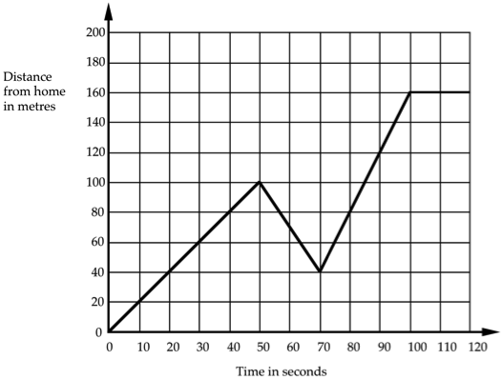
Interpreting a distance–time graph
Distance from home in meters.
Every morning Tom walks along a straight road from his home to a bus stop, a distance of 160 meters. The graph shows his journey on one particular day.
1. Describe what may have happened.
You should include details like how fast he walked.

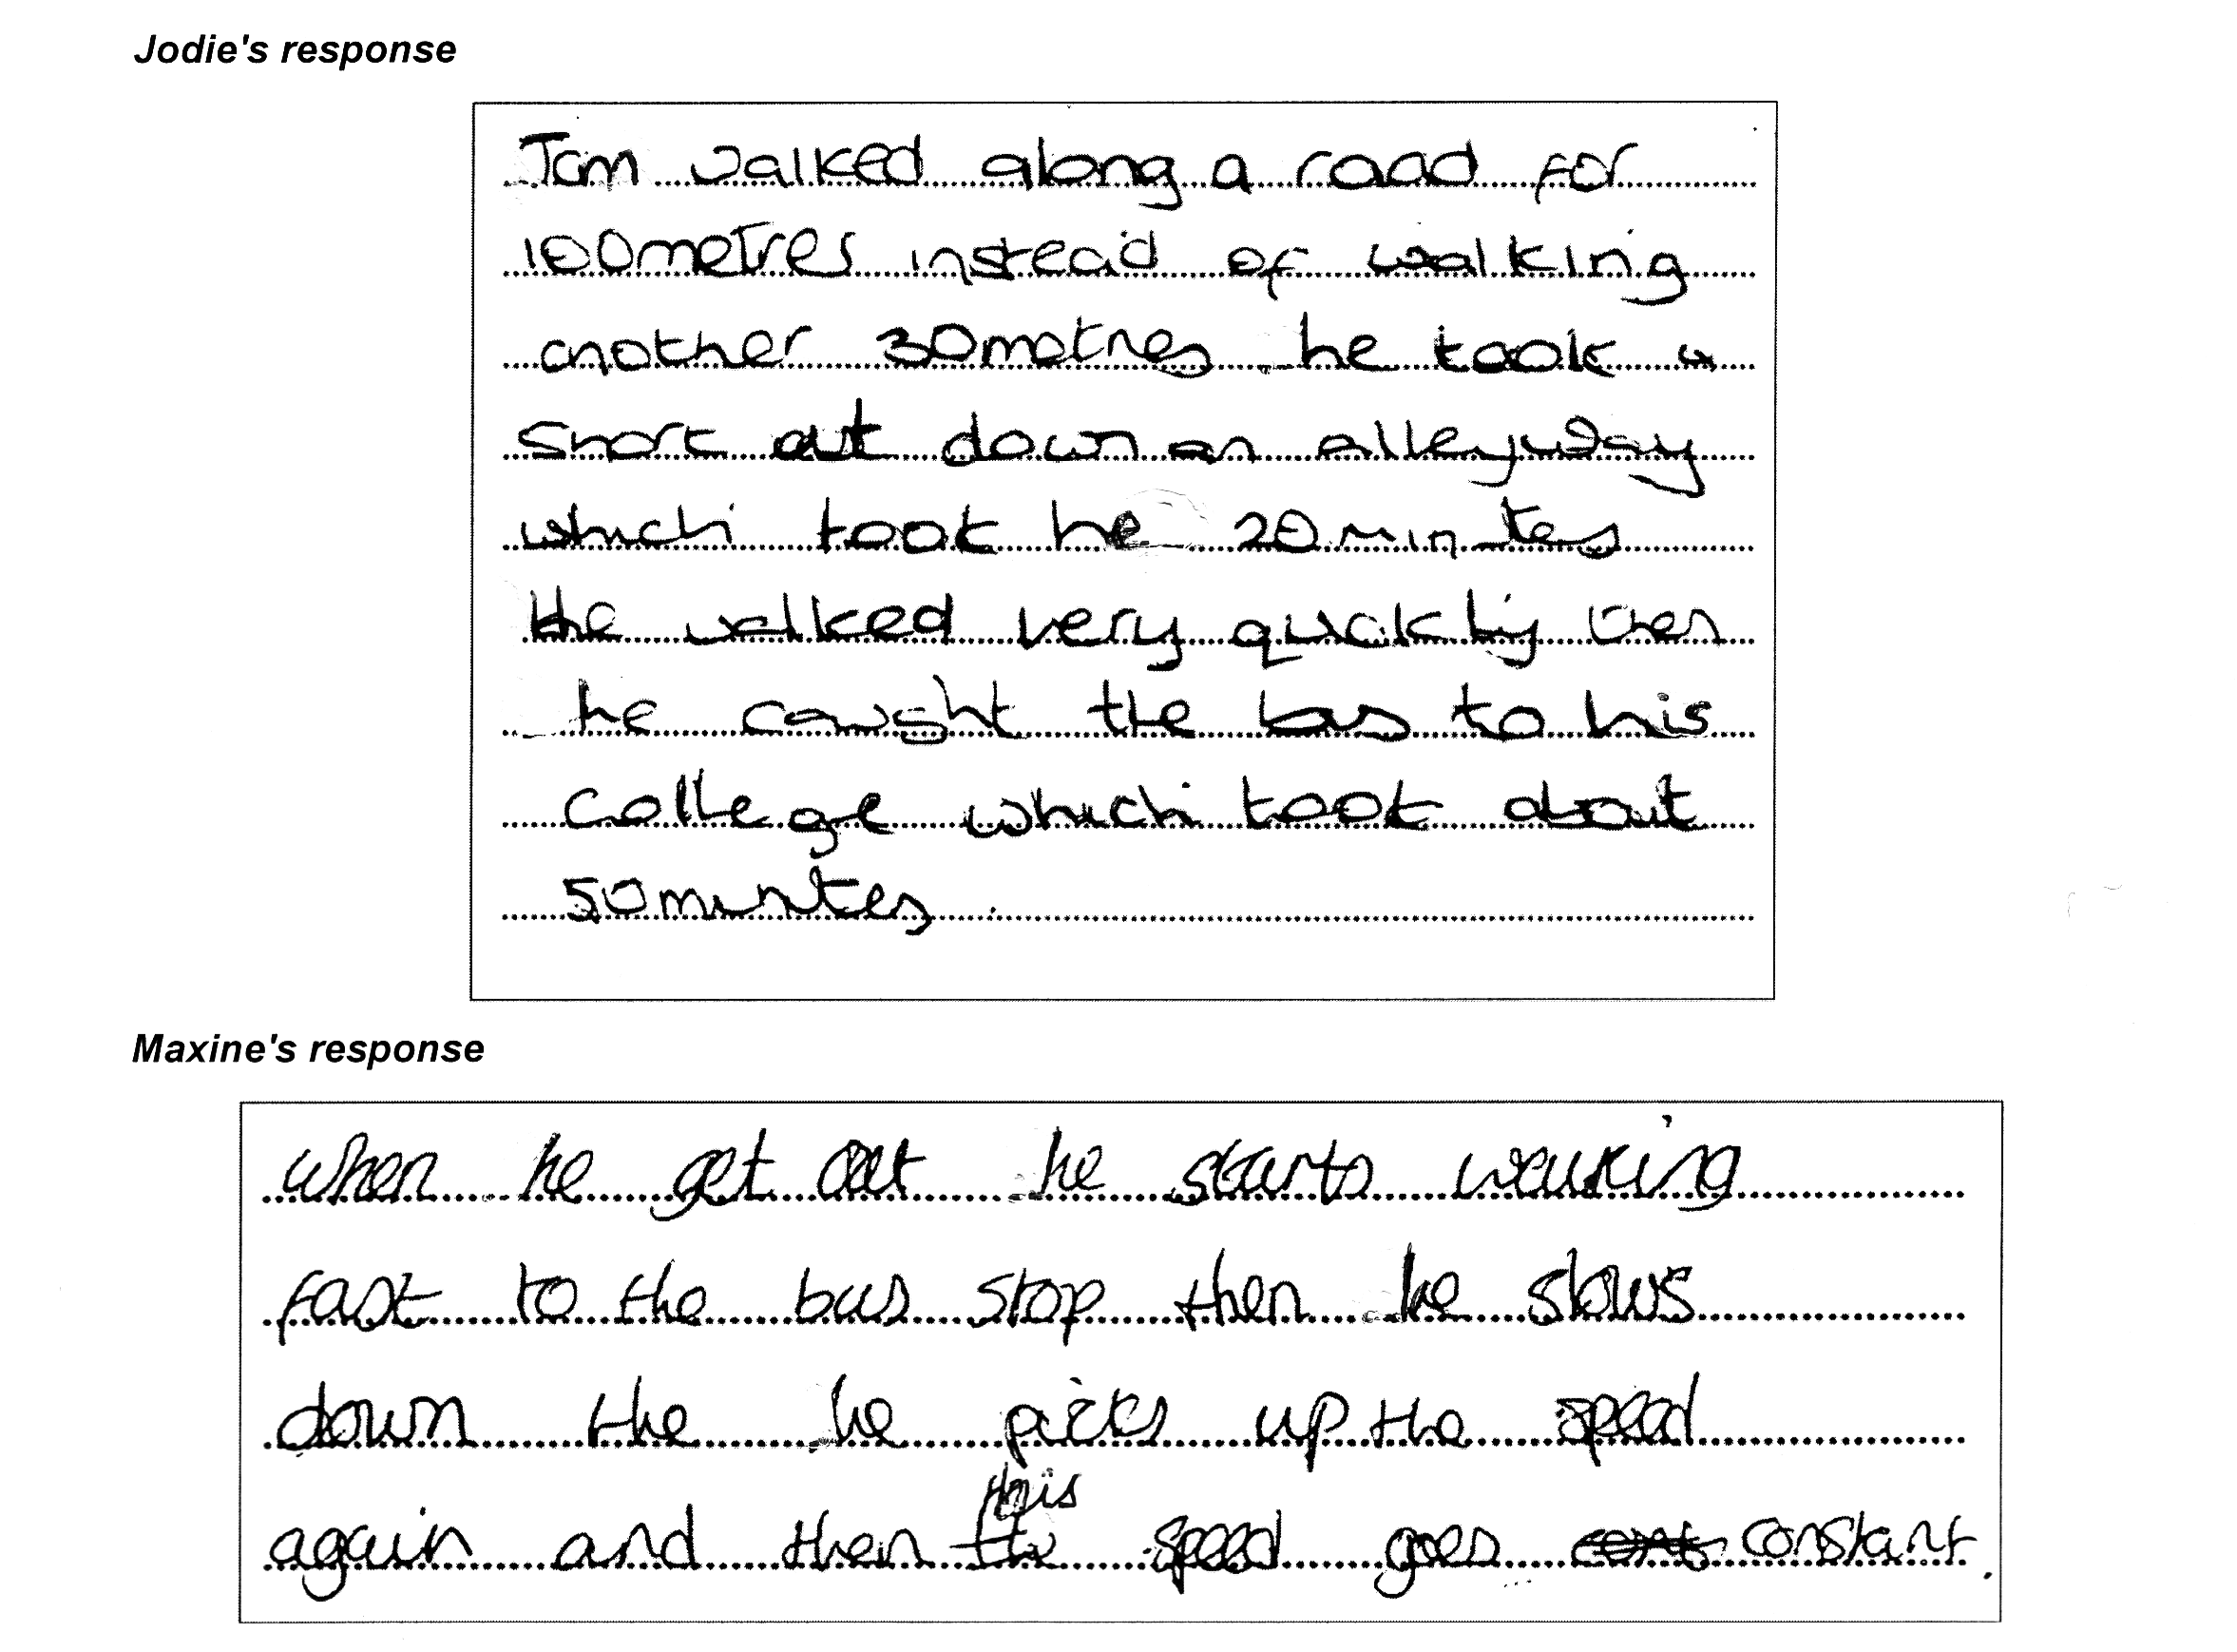

Percent changes
( )
- Maria sees a dress in a sale. The dress is normally priced at $56.99.
The ticket says that there is 45% off.
She wants to use her calculator to work out how much the dress will cost.
It does not have a percent button.
Which keys must she press on her calculator?
Write down the keys in the correct order.
(You do not have to do the calculation.)
- In a sale, the prices in a shop were all decreased by 20%.
After the sale they were all increased by 25%.
What was the overall effect on the shop prices?
Explain how you know.

George's response

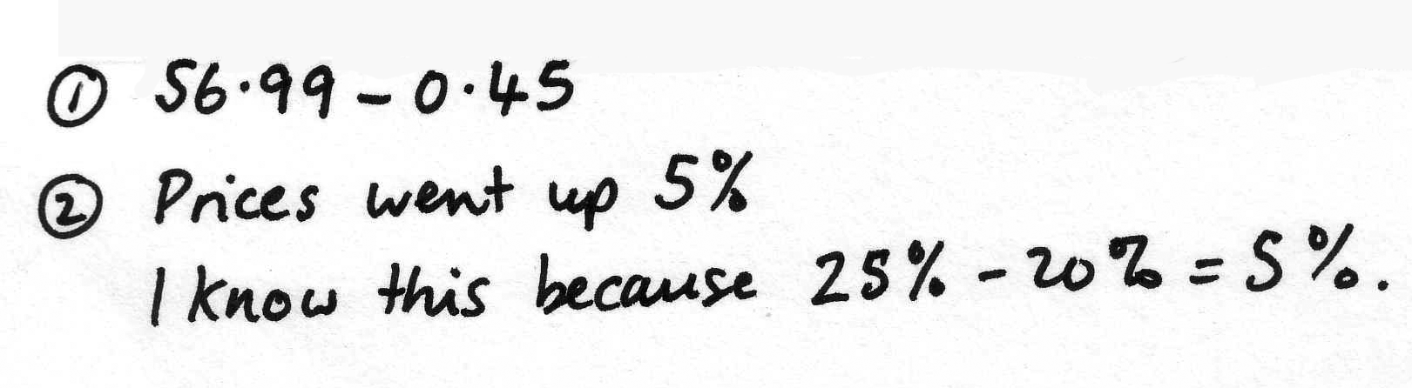

Jurgen's response

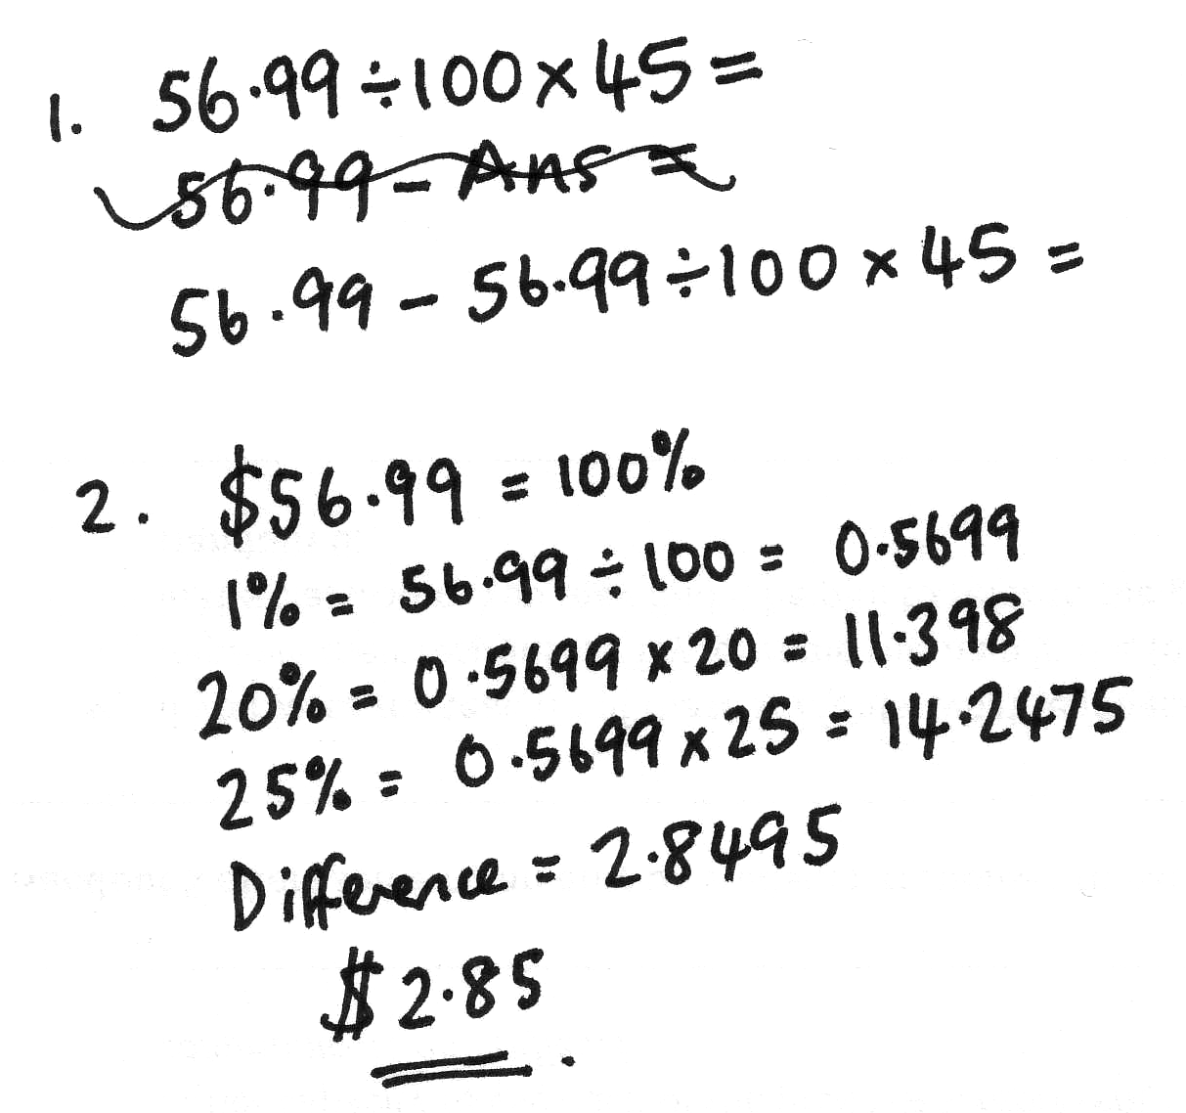

Interpreting expressions

Britney's response

Handout 3: Sample follow-up questions

Distance-time graphs: Common issues

Percent changes: Common issues

Interpreting expressions: Common issues

Handout 4: Generalizations commonly made by students

What other examples can you add to this list?
Can you think of any misconceptions you have had at some time?
How were these overcome?

0.567 > 0.85
The more digits a number has, the larger is its value.

3 ÷ 6 = 2
You always divide the larger number by the smaller one.

0.4>0.62
The fewer the number of digits after the decimal point, the larger is its value.
It's like fractions.

5.62 x 0.65 > 5.62
Multiplication always makes numbers bigger.

1 gallon costs $5.60; 4.2 gallons cost $5.60 x 4.2; 0.22 gallons cost $5.60 ÷ 0.22
If you change the numbers in a question, you change the operation you have to do.

Area of rectangle ≠ Area of triangle
If you dissect a shape and rearrange the pieces, you change the area.

Angle A is greatest. Angle C is greatest.
The size of an angle is related to the size of the arc or the length of the arms of the angle.

If x+4 < 10, then x = 5.
Letters represent particular numbers.

3 + 4 = 7 + 2 = 9 + 5 = 14
Equals' means 'makes'.

In three rolls of a die, it is harder to get 6,6,6 than 2,4,6.
Special outcomes are less likely than more representative outcomes.

Handout 5: Principles to discuss
These principles are backed up by research evidence.
Discuss the implications for your own teaching.

- Teaching approaches that encourage the exploration of misconceptions through discussions result in deeper, longer-term learning than approaches that try to avoid mistakes by explaining the ‘right way’ to see things from the start.

- It is helpful if discussions focus on known difficulties. Rather than posing long lists of questions, it is better to focus on a challenging task and encourage a variety of interpretations to emerge, so that students can compare and evaluate their ideas.

- Questions can be juxtaposed in ways that create a tension (sometimes called a ‘cognitive conflict’) that needs resolving. Contradictions arising from conflicting methods or opinions create awareness that something needs to be learned. For example, asking students to say how much medicine is in each of the following syringes may result in answers such as “1.3ml, 1.12ml and 1.6ml”. “But these quantities are all the same!” This provides a start for a useful discussion on the denary nature of decimal notation.

- Activities should provide opportunities for meaningful feedback. This does not mean providing summative information, such as the number of correct or incorrect answers. More helpful feedback is provided when students compare results obtained from alternative methods until they realize why they get different answers.

- Sessions include time for whole group discussion in which new ideas and concepts are allowed to emerge. This requires sensitivity so that students are encouraged to share tentative ideas in a non-threatening environment.

- Opportunities should be provided for students to ‘consolidate’ what has been learned through the application of the newly constructed concept.

Handout 6: Structure of the Concept lessons

Broadly speaking, each Concept Formative Assessment Lesson is structured in the following way, with some variation, depending on the topic and task:

- (Before the lesson) Students complete an assessment task individually
This assessment task is designed to clarify students’ existing understandings of the concepts under study. The teacher assesses a sample of these and plans appropriate questions that will move student thinking forward. These questions are then introduced in the lesson at appropriate points.

- Whole class introduction
Each lesson begins with the teacher presenting a problem for class discussion. The aim here is to intrigue students, provoke discussion and/or model reasoning,

- Collaborative work on a substantial activity
At this point the main activity is introduced. This activity is designed to be a rich, collaborative learning experience. It is both accessible and challenging; having multiple entry points and multiple solution paths. It is usually done with shared resources and is presented on a poster.
Four types of activity are commonly used as shown in Handout 6. Students are involved in:
  - classifying mathematical objects & challenging definitions
  - interpreting multiple representations
  - evaluating conjectures and assertions
  - modifying situations & exploring their structure

These will be explored more fully later in this module. It is not necessary for every student to complete the activity. Rather we hope that students will come to understand the concepts more clearly.

- Students share their thinking with the whole class
Students now share some of their learning with other students. It is through explaining that students begin to clarify their own thinking. The teacher may then ask further questions to provoke deeper reflection.

- Students revisit the assessment task
Finally, students are asked to look again at their original answers to the assessment task. They are either asked to improve their responses or are asked to complete a similar task. This helps both the teacher and the student to realize what has been learned from the lesson.

Handout 7: Some genres of activity used in the Concept lessons

The main activities in the concept lessons are built around the following four genres. Each of these types of activity is designed to provoke students to reason in different ways; to recognize properties, to define, to represent, to challenge conjectures and misconceptions, to recognize deeper structures in problems.

- Classifying mathematical objects
Mathematics is full of conceptual ‘objects’ such as numbers, shapes, and functions. In this type of activity, students examine objects carefully, and classify them according to their different attributes. Students have to select an object, discriminate between that object and other similar objects (what is the same and what is different?) and create and use categories to build definitions. This type of activity is therefore powerful in helping students understand different mathematical terms and symbols, and the process by which they are developed.

- Interpreting multiple representations
Mathematical concepts have many representations; words, diagrams, algebraic symbols, tables, graphs and so forth. These activities allow different representations to be shared, interpreted, compared and grouped in ways that allow students to construct meanings and links between the underlying concepts.

- Evaluating mathematical statements
These activities offer students a number of mathematical statements or generalizations. These statements may typically arise from student misconceptions, for example: “The square root of a number is smaller than the number.” Students are asked to decide on their validity and give explanations for their decisions. Explanations usually involve generating examples and counterexamples to support or refute the statements. In addition, students may be invited to add conditions or otherwise revise the statements so that they become ‘always true’.
- Exploring the structure of problems
In this type of activity, students are given the task of devising their own mathematical problems. They try to devise problems that are both challenging and that they know they can solve correctly. Students first solve their own problems and then challenge other students to solve them. During this process, they offer support and act as ‘teachers’ when the problem solver becomes stuck. Creating and solving problems may also be used to illustrate doing and undoing processes in mathematics. For example, one student might draw a circle and calculate its area. This student is then asked to pass the result to a neighbor, who must now try to reconstruct the circle from the given area. Both students then collaborate to see where mistakes have arisen.

Handout 8: Classifying mathematical objects

Similarities and differences
Show students three objects.  "Which is the odd one out?"  "Describe properties that two share that the third does not."  "Now choose a different object from the three and justify it as the odd one out." | (a) (b) (c)

Properties and definitions
Show students an object.  "Look at this object and write down all its properties."  "Does any single property constitute a definition of the object? If not, what other object has that property?"  "Which pairs of properties constitute a definition and which pairs do not?" | 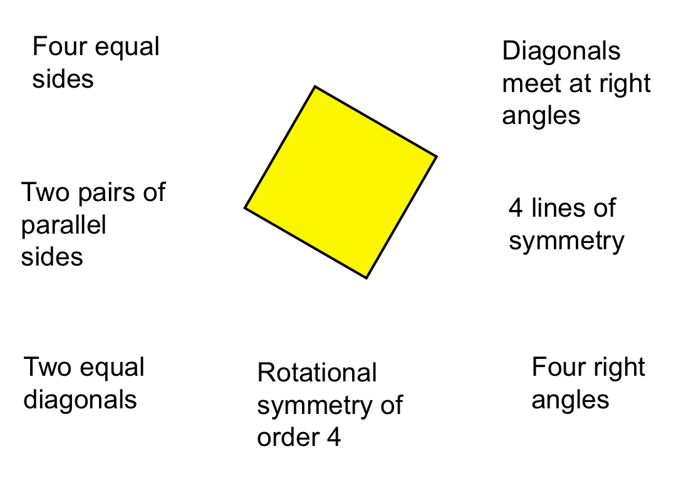

Creating and testing a definition
Ask students to write down the definition of a polygon, or some other mathematical word.  "Exchange definitions and try to improve them."  Show students a collection of objects.  "Use your definition to sort the objects."  "Now improve your definitions." | Which of these is a polygon according to your definition?  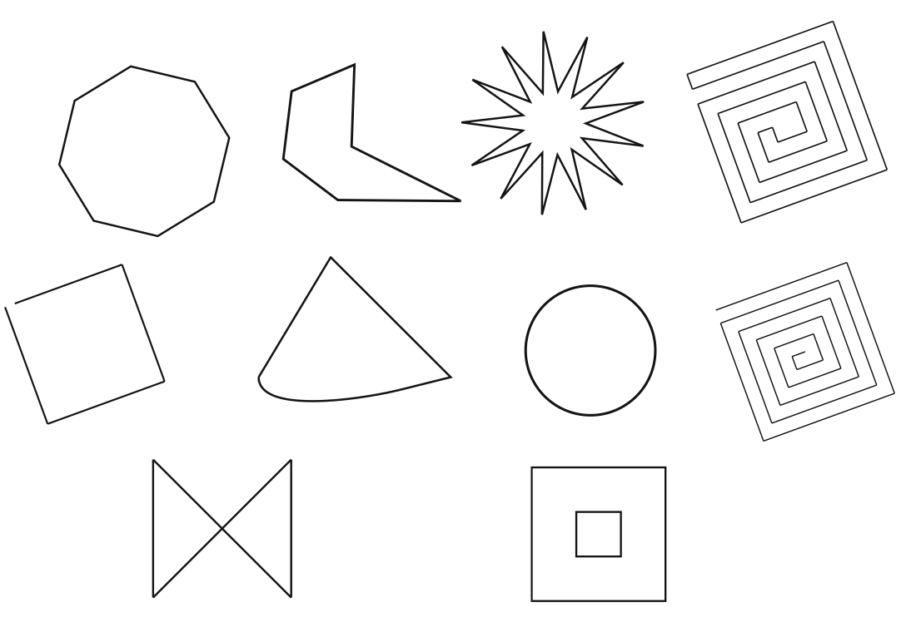

Classifying using a two-way table
Give students a two-way table to sort a collection of objects.

"Create your own objects and add these to the table."

"Try to justify why particular entries are impossible to fill."

“Classify the objects according to your own categories. Hide your category headings.
Can your partner identify the headings from the way you have sorted the objects?”

Handout 9: Interpreting multiple representations

Each group of students is given a set of cards. They are invited to sort the cards into sets, so that each set of cards have equivalent meaning. As they do this, they have to explain how they know that cards are equivalent. They also construct for themselves any cards that are missing. The cards are designed to force students to discriminate between commonly confused representations.

Card Set A: Algebra expressions

Card Set B: Verbal descriptions

Card Set C: Tables

Card Set D: Areas

Swan, M. (2008), A Designer Speaks: Designing a Multiple Representation Learning Experience in Secondary Algebra. Educational Designer: Journal of the International Society for Design and Development in Education, 1(1), article 3.

Handout 10: Evaluating mathematical statements
Each group of students is given a set of statements on cards. Usually these statements are related in some way. They have to decide whether they are always, sometimes or never true.
- If they think it is always or never true, then they must try to explain how they can be sure.
- If they think it is sometimes true, they must define exactly when it is true and when it is not.

Pay rise  Max gets a pay rise of 30%.  Jim gets a pay rise of 25%.  So Max gets the bigger pay rise. | Sale  In a sale, every price was reduced by 25%. After the sale every price was increased by 25%. So prices went back to where they started.
Area and perimeter  When you cut a piece off a shape you reduce its area and perimeter. | Right angles  A pentagon has fewer right angles than a rectangle.
Birthdays  In a class of ten students, the probability of two students being born on the same day of the week is one. | Lottery  In a lottery, the six numbers  3, 12, 26, 37, 44, 45  are more likely to come up than the six numbers 1, 2, 3, 4, 5, 6.
Bigger fractions  If you add the same number to the top and bottom of a fraction, the fraction gets bigger in value. | Smaller fractions  If you divide the top and bottom of a fraction by the same number, the fraction gets smaller in value.
Square roots  The square root of a number is less than or equal to the number | Series  If the limit of the sequence of terms in an infinite series is zero, then the sum of the series is zero.

Handout 11: Students modifying a given problem

Here is a typical word problem from a textbook.

The candles problem

A student wants to earn some money by making and selling candles.
Suppose that she can make 60 candles from a $50 kit, and that these will each be sold for $4.
How much profit will she make?

After answering such a question, we might explore its structure and attempt some generalizations.
First remove all the numbers from the problem:

 |  | k
The cost of buying the kit:  (This includes the molds, wax and wicks.) | $ | 50
 |  | n
The number of candles that can be made with the kit: |  | 60 | candles
 |  | s
The price at which he sells each candle: | $ | 4 | per candle
 |  | p
Total profit made if all the candles are sold: | $ | 190

Now we can ask the following, first using numerical values, then using variables:

- How did we calculate the profit p using the given values of k, n, and s?
Would your method change if the values of k, n, and s were different?
- Write in the profit and erase one of the other values: the selling price of each candle, s.
How can you figure out the value of s from the remaining values of k, n and p?
Repeat, but now erase the value of a different variable and say how it may be reconstructed from the remaining values.
- Suppose you didn’t know either of the values of n and p, but you knew the remaining values.
How will the profit depend on the number of candles made? Plot a graph.
Repeat for other pairs of variables.
- Write down four general formulas showing the relationships between the variables.
p = ……………..… s = ……………..… n = ……………..… k = ……………..…

Handout 12: Students creating problems for each other

Ask students to work in pairs. Each creates a problem for the other to solve.

Doing: The problem poser… | Undoing: The problem solver…
- generates an equation step-by-step, starting with, say, x = 4 and ‘doing the same to both sides’ | - solves the resulting equation:  $\frac{\text{10}x+9}{8}−7\text{=-}0\text{.}\text{875}$
- draws a rectangle and calculates its area and perimeter. | - tries to draw a rectangle with the given area and perimeter.
- writes down an equation of the form y=mx+c and plots a graph. | - tries to find an equation that fits the resulting graph.
- expands an algebraic expression such as (x+3)(x-2) | - factorizes the resulting expression:  - x² + x - 6
- writes down a polynomial and differentiates it | - integrates the resulting function
- writes down five numbers  and finds their mean, median, range | - tries to find five numbers with the given mean, median and range.

